

**‘*Meth* Clothing’**

**A Website Design Project**

**through AGILE methodology**

**By**

***TEAM MATRIX RELOADED***

* **Emil Parvanov (G00375200)**
* **David Purtill (G00374622)**
* **Walter Regan (10010255)**
* **Paul Whent (G00375061)**
* **Stephen Welch (G00374729)**

**40456 PROJECT MANAGEMENT**

**Date: 30/03/2020**

**Submitted to : Joseph Corr**

**Table of Contents**

**Project Introduction**1

**Assignment 01**2

Introduction3

Content

Summary

**Assignment 02**4

Introduction5

Content

Summary

**Assignment 03**6

Introduction7

Content

Summary

**Assignment 04**8

Introduction9

Content

Summary

**Assignment 05**10

Introduction11

Content

Summary

**Table of Contents cont.**

**Project Summary**??

**Project Conclusions**??

**References/Bibliography**12

**Appendix I (Assignment 04 OneNote)**14

Guide15

Team Matrix Reloaded16

Wednesday 29th January17

Thursday 6th February19

Wednesday 12th February21

Thursady 20th February25

Monday 24th February26

Wednesday 26th February27

Friday 28th February28

Wednesday 4th March29

Monday 9th March32

Thursday 12th March33

**Appendix II (Plagiarism Disclaimer Forms)** 34

Plagiarism Disclaimer (Emil Parvanov) 35

Plagiarism Disclaimer (David Purtill) 36

Plagiarism Disclaimer (Walter Regan) 37

Plagiarism Disclaimer (Paul Whent) 38

Plagiarism Disclaimer (Stephen Welch) 39

??????????????????????

Project Introduction

This is a project for

Assignment 01

**Introduction**

The objective of this assignment was to assemble a team, create a name inspired by a Sci-Fi movie, agree on the (initial) Agile roles to be assumed by team members and to begin bonding/working as a team for the tasks ahead. A team photograph was required as well as the setting up of a Github repository for the team to push code to during the software development phase of the project ahead.

**Content**

**Summary**

Assignment 02

**Introduction**

**Content**

**Summary**

Assignment 03

**Introduction**

.

**Content**

**Summary**

Assignment 04

**Introduction**

**Content**

**Summary**

Assignment 05

**Introduction**

**Content**

**Summary**

References

Appendix

**Assignment 04**

**Matrix Reloaded OneNote posts**

28 February 2020 22:23

**Guide:**

**Planning**

**• The goal(s) for the week**

**• What each team member is planning to work on**

**• List of issues**

**Progress**

**• Progress made on goal(s)**

**• What each team member accomplished/achieved**

**•Issues resolved/not resolved/new**

**Events details**

**• Team meetings (capture outputs)**

**• Brainstorming sessions (capture outputs)**

**Artefacts**

**• Artefacts produced**

***Team MATRIX RELOADED***

06 February 2020 19:22

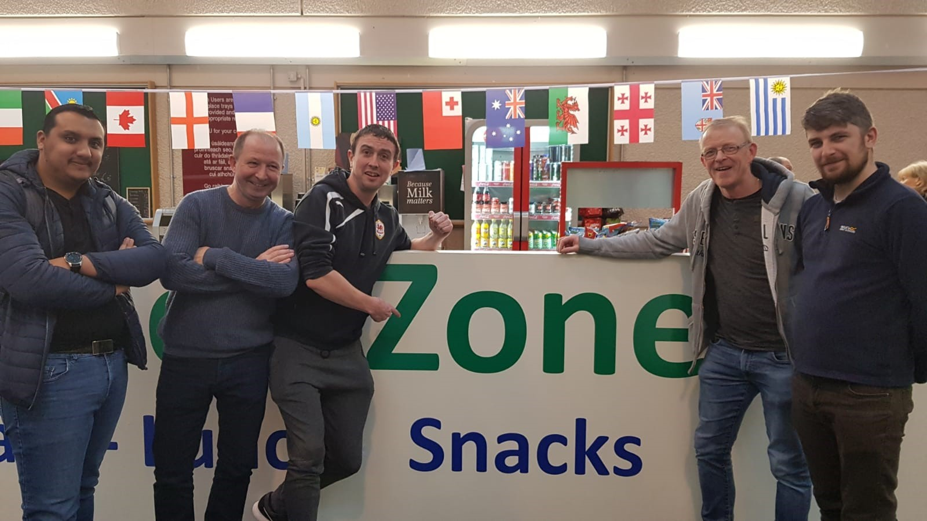

**Product Owner – Walter Regan(10010255)**

**Scrum Master - David Purtill (G00374622)**

**Developer - Emil Parvanov(G00375200)**

**Developer - Stephen Welch (G00374729)**

**Tester - Paul Whent (G00375061)**

Submitted By: Paul Whent

On behalf of Team 'Matrix Reloaded'

**Wednesday 29th January 2020 Scrum Meeting - Study Room 11 All team members present. 13:00 - 14:00**

06 February 2020

18:25

The prime goals of today's meeting, as agreed by all Team members were as follows:

* To agree on a Team Working Agreement and put our names to it.

* To decide on the project requirements.

This much needed supplementary meeting proved to be quite productive.

A good round the table brainstorming session produced consensus for the statements to be added to our Team Working Agreement on the Whiteboard. This list came quite easily as all the team members are committed to the process, and eager to see it through successfully, each appreciating the need for agreed rules for the common goal.

Having agreed on the list of 10 items in our Working Agreement, we each signed our names at the bottom and photographed it ready for submission.

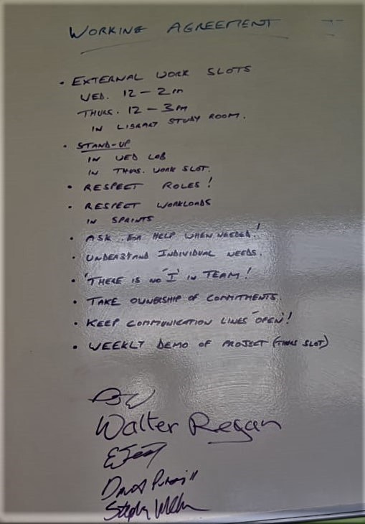

Next we began to focus in on our Project requirements and User stories. We each began writing short User Stories on Post-It notes and then put them up on the Whiteboard.

By the end of the session we had a significant number of stories on the board but had run out of time, so agreed to continue the process at the next meeting.

Submitted By: Paul Whent

On behalf of Team 'Matrix Reloaded'

**Working Agreement**

Wednesday, February 5, 2020

11:35 AM

Working Agreement

External Work Slots

· Wed: 12 – 2pm

· Thurs: 12 – 3pm

(in library study room)

Stand ups

· In Wed lab

· In Thurs meet up

· Respect roles!

· Respect Workloads in sprint.

· Ask for help when needed.

· Respect roles in sprint.

· Understand individual needs.

· There is no ‘I’ in team.

· Take ownership of commitments.

· Keep communication lines open.

· Weekly demo of project in allocated time slots.

Through a group meeting we discussed what the ground rules were for the working agreement. Some were accepted and some were not Paul wrote them up on the white board for all to see, this was done while brain-storming the idea/rules been set for the working agree

**Thursday 6th February 2020 Scrum Meeting - Study Room 5b All team members present. 13:00 - 15:00**

06 February 2020

16:54

The goals set ahead of today's meeting, as agreed by all Team members were as follows:

* To size the User Stories that were compiled during last Thursday's meeting.

* To define User Story READY

* To define User Story DONE

* To select the User Stories to be included in the first Sprint

* To add User Stories to the JIRA Backlog to assist us in tracking and scheduling our Sprints.

* To select User Stories to be included and completed in the first Sprint.

* To set up and begin posting to our OneNote notebook.

Today's meeting was conducted apace as all team members appreciated the need to make real progress to ensure the successful completion of the goals agreed upon, within our two-hour slot.

Following a brief Stand Up and reiteration of the goals, David and Stephen set up the Whiteboard with the User Story Post-It notes that we had completed previously (at last week's meeting), and together with the Product Owner, Walter, began to discuss which stories might be moved from the Product Backlog column into the First Sprint column and how to size them. Emil and Paul began to set up the Jira and One Note accounts, so that we could use these tools to track and schedule our Sprints, as well as provide a record of our work on the project.

It soon became obvious which User Stories were most important to the functionality of the website that the Product Owner wished to develop, there were four, which given our experience (or lack of) should be a manageable Team Velocity for a very first Sprint . The consensus amongst the team was that the best way to size these would be for each individual team member to anonymously size them on Post-It notes, and then to take the average of those and assign size to each User Story, which we subsequently did.

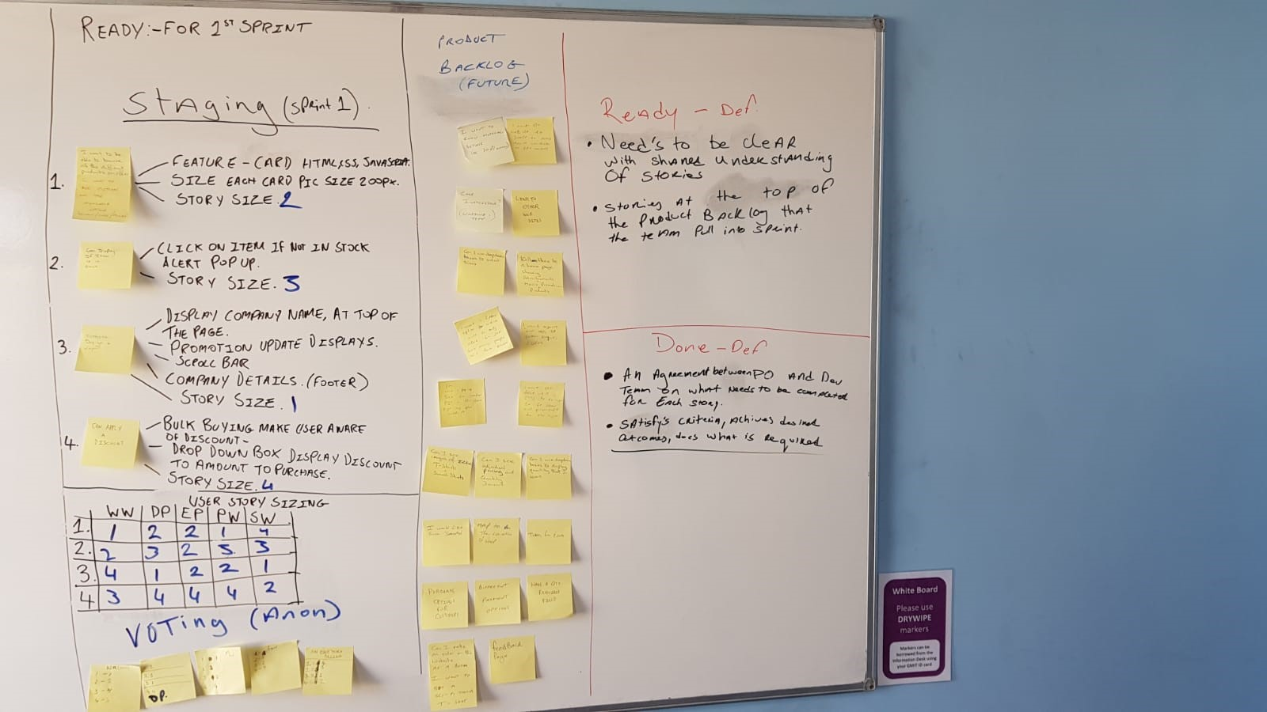

The team collaborated closely to ensure that everyone understood what was going on and at appropriate points came together to get consensus and make decisions.

Paul agreed to post a summary of the meeting on OneNote (also for last week's meeting) and Stephen said he would submit Assignment 3 which is due on Monday.

Submitted By: Paul Whent

On behalf of Team 'Matrix Reloaded'

**Wednesday 12th February 2020 Release Planning Meeting - Study Room 8 All team members present. 12:30 - 14:00**

x`

12 February 2020

18:29

The agreed objective of today's meeting, which was actually our Release Planning Meeting ready for next week's First Sprint (due to time constraints), was to follow on from last week's meeting where we already estimated the number of story points for the team velocity and preliminarily agreed which stories to include in the sprint. Today we would review last weeks decisions, make a decision on the final Release Plan and hold a Team Confidence Vote for same.

First, David resurrected last weeks chart, so that we could review our thought processes from last week and make any adjustments, if needed. There were a few minor points raised about the stories that we had selected and their sizing, but the consensus was that we would stick with what we had previously agreed on, time being of the essence.

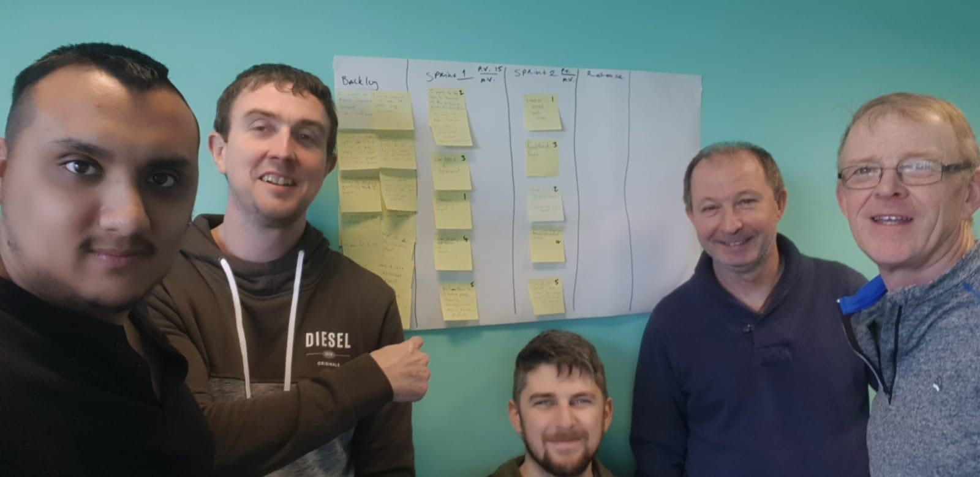

One point that arose was the method that we had used to size and select the stories for the sprint. It had become evident from the videos that Joe had shown in today's Lab, that we perhaps, should have sized all the stories in the Product Backlog before selection, rather than selecting those we thought should be prioritised and sizing just those. We acknowledged the mistake but decided to learn from it and move forward rather than back, agreeing to implement the correct method in our next project.

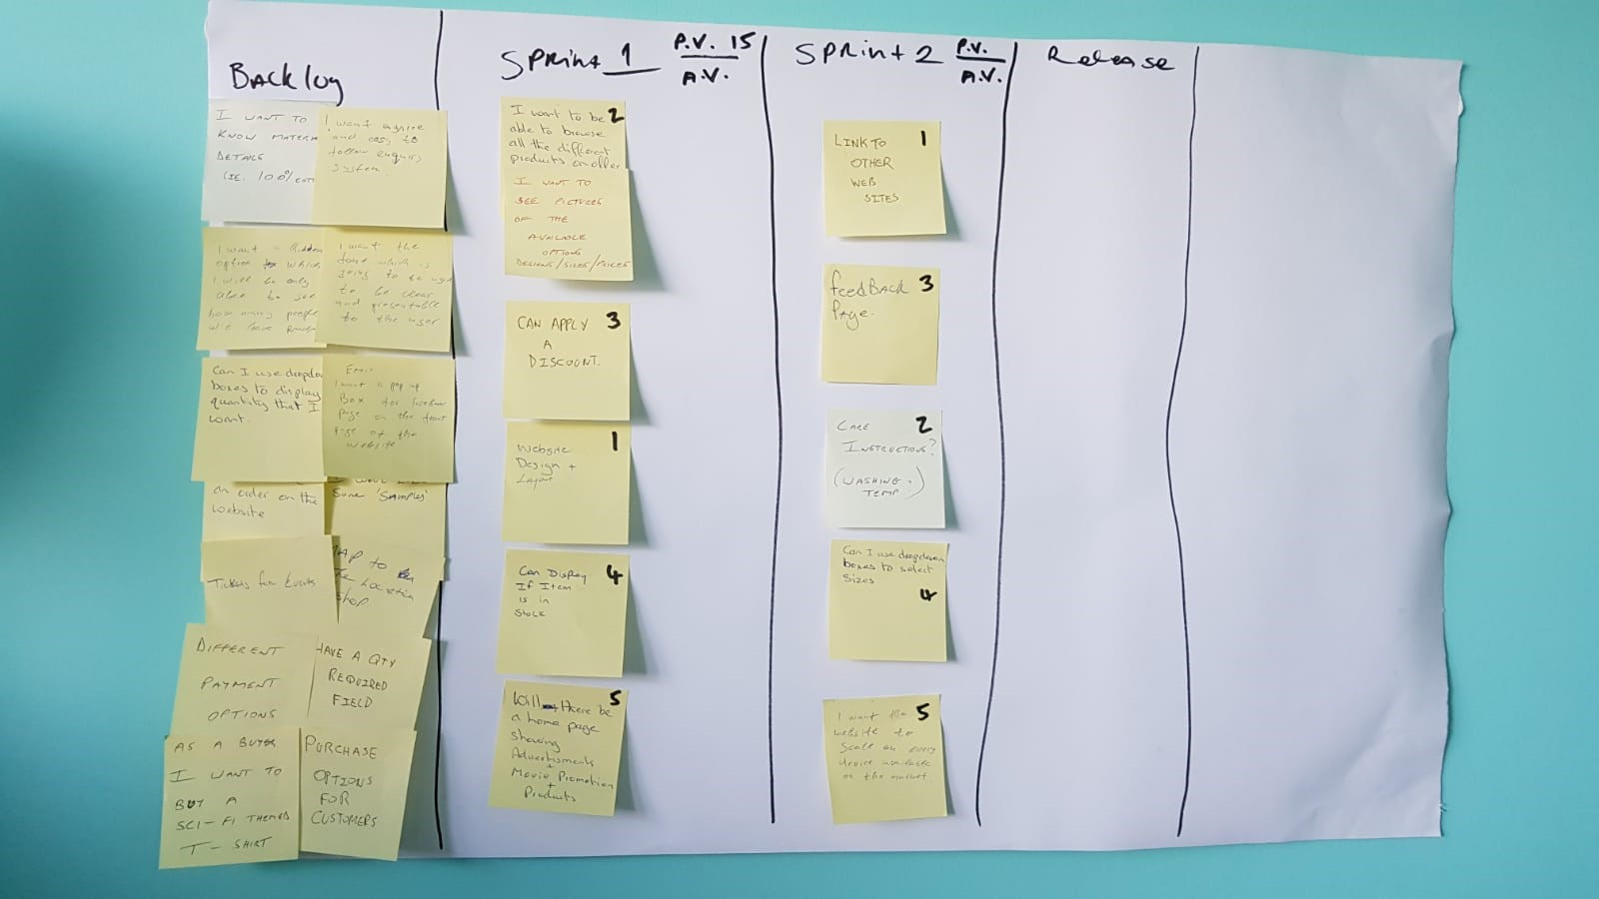

In discussing the breakdown of stories into tasks it soon became evident that our stories were pretty much already manageable enough to be considered tasks in themselves, so the developers, Stephen and Emil, were more than happy to work with what we had, for this sprint at least.

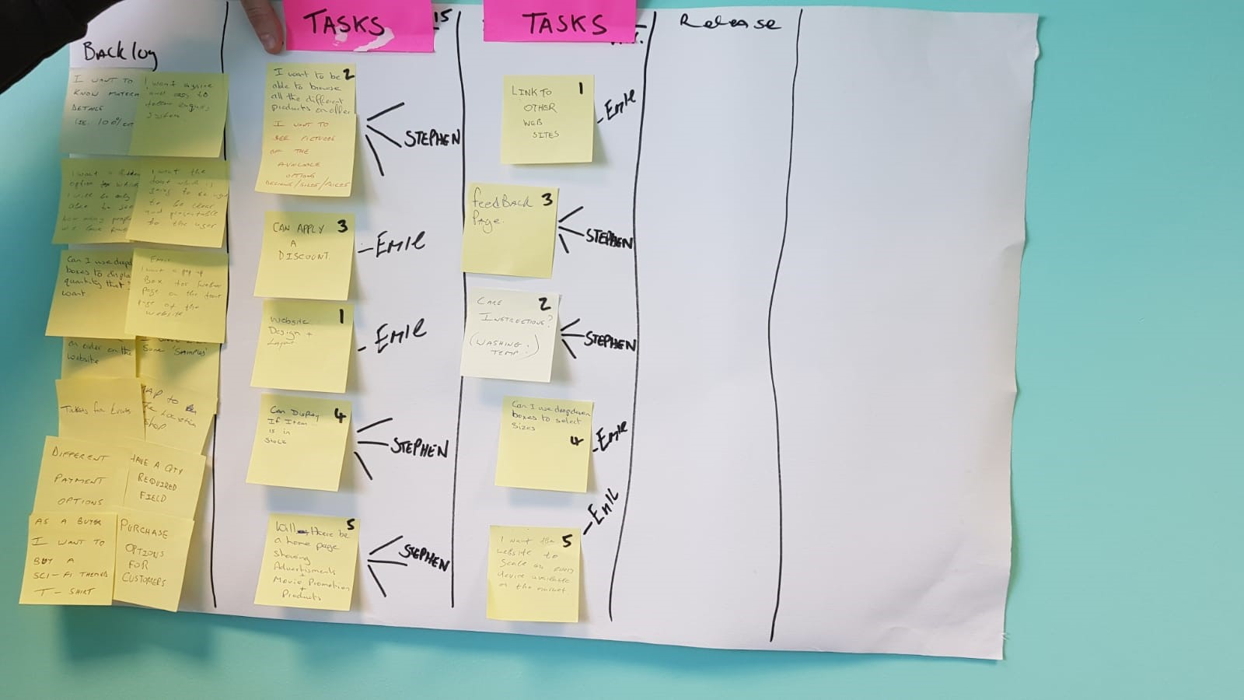

After much discussion between all team members, the product owner, Walter, called for a Team Confidence Vote to gauge the confidence of team members on the Release Plan and it's ability to deliver what he requires. This was done using Post-It notes, each team member rating on a scale of 1 to 10 (Not Confident to Very Confident), how they felt about the agreed plan. This resulted in a fairly high confidence in the plan, so we agreed to adopt the Release Plan going forward.

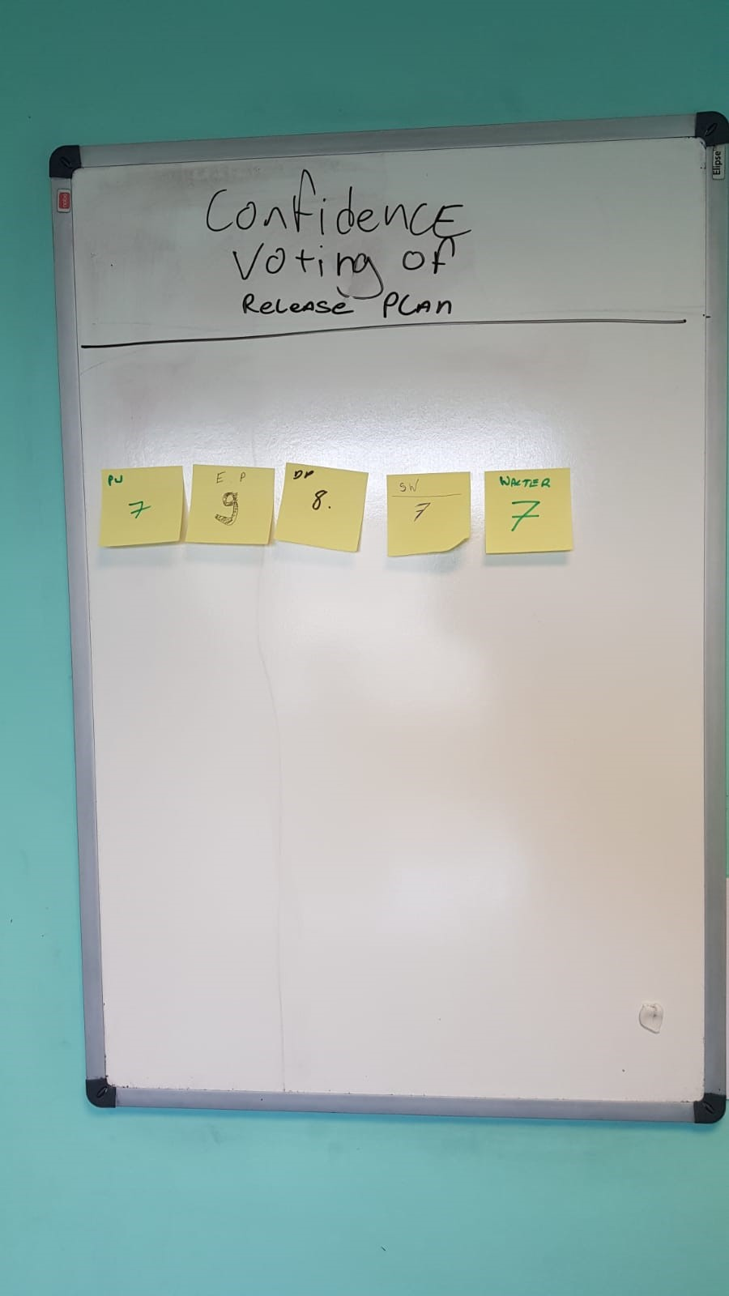

Bringing the meeting to a conclusion, Paul said he would post a summary of the meeting on OneNote as last week and also research in more detail the requirements for Testing, David and Walter agreed to investigate any tools available through Jira, or elsewhere, for compiling a Burndown Chart, while Stephen and Emil would collaborate in preparation for the Sprint, by reviewing any coding practices that they needed to review/revise.

Submitted By: Paul Whent

On behalf of Team 'Matrix Reloaded'

**Thursday 20th February 2020 Team 'Development/Focus Session' - Study Room 1 All team members present. 13:00 - 15:00**

Friday, February 21, 2020

10:38 PM

The purpose of this Team 'Development/Focus Session' was to Focus the team resources to ensure adequate progress of the First Sprint which began on Monday.

Firstly, Emil and Stephen gave a briefing on the steps they had already taken in coding of their user story tasks. A few questions arose about the finer details but overall the other team members including the P.O. were impressed by the good start that has already been made under considerable time constraints from other coursework and external commitments.

David and Walter reported that they had made good progress in familiarizing themselves with the Jira project management software and would now be in a position to update the Sprint Burndown Chart as required.

Paul had done research of Testing options, but felt most of them were totally overkill for the scale of our small project and would need unavailable time investment to become in any way competent at their use, so he stated his intention, in this project, to limit the testing to a simple listing of the functionality required by the P.O. for each user story and scenarios that might be encountered when using the various functions to check if they work as expected.

One issue that did come up was the use of Git/GitHub, most of the team were not comfortable with their understanding of its use. Fortunately, Emil does have a fairly good understanding and proceeded to give us all a crash-course in its use. Hopefully, we can now use Git with a little more confidence.

The remainder of the meeting was taken up with further coding.

Submitted By: Paul Whent

On behalf of Team 'Matrix Reloaded'

**Monday 24th February 2020**  **Meeting - All team members present. 13:00 - 13:30**

Friday, February 28, 2020

**Stand-Up**

Paul: OneNote updated and submitted Friday Evening

Test Documentation initiated in MS Excel, Format being finalised and Test scenarios to be prepared. Still not that comfortable with the use of GitHub.

Stephen: Coding progressing well considering his work commitments over the weekend.

Emil: Coding progressing well with User Stories almost complete and ready for testing.

David: Jira Burndown chart updated.

Meeting

Stephen and Emil presented the current status of the website, giving a demonstration of the design and functionality of the two user stories that are now ready for testing.

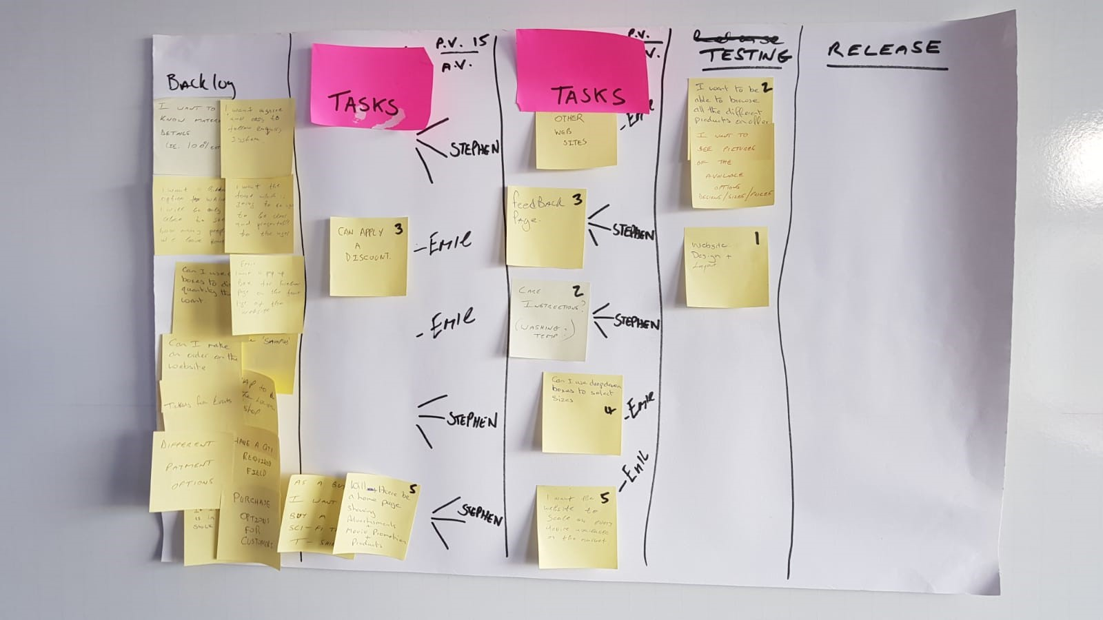

David updated the Scrum board to reflect the user stories now ready for Paul to test ('Website Design and Layout' plus 'Ability to browse products on offer, including sizes and pricing).

Emil and David gave a further demonstration of the use of the commands to push to and pull from GitHub as both Paul and Walter were still not comfortable with it's use.

Submitted By: Paul Whent

On behalf of Team 'Matrix Reloaded'

**Wednesday 26th February 2020**  **Meeting - Study Room 4**

**All team members present. 13:00 - 15:00**

Friday, February 28, 2020

Stephen and Emil gave another demonstration of the design and functionality of all the user stories that are now ready for testing.

David updated the Scrum board to reflect the user stories now ready for Paul to test.

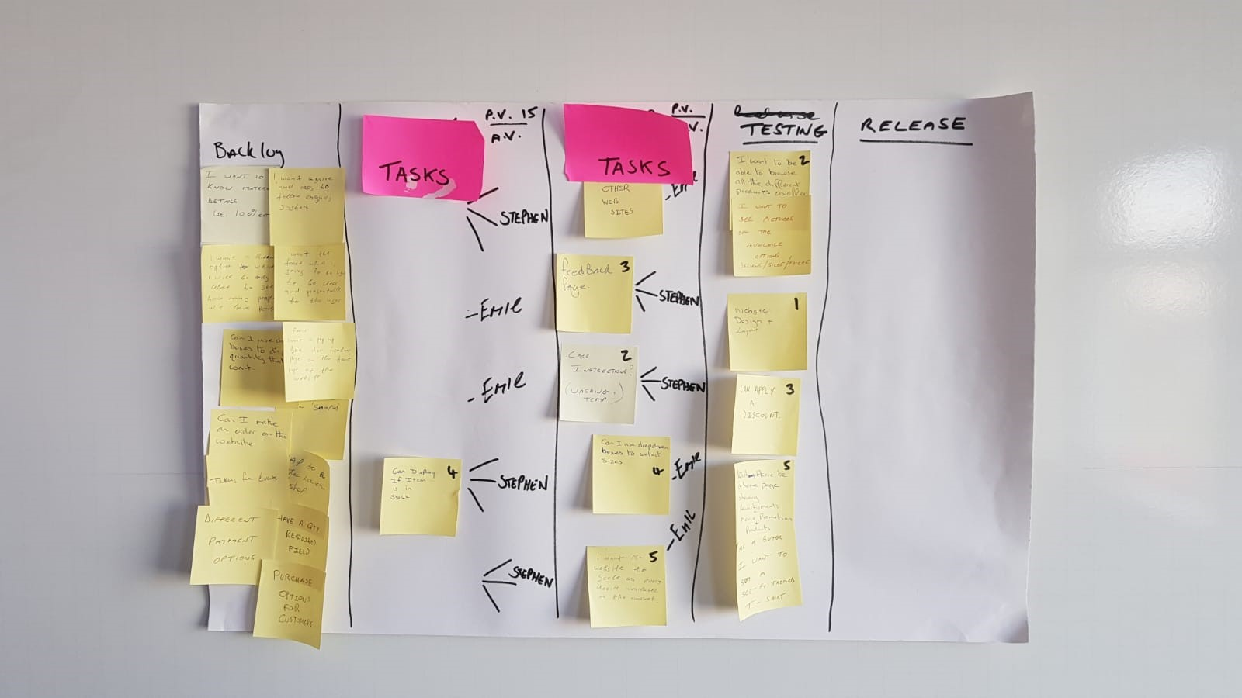

Submitted By: Paul Whent

On behalf of Team 'Matrix Reloaded'

**Friday 28th February 2020**  **Sprint Review Demo Meeting - Study Room 1 All team members present. 13:00 - 15:00**

Friday, February 28, 2020

The prime purpose of this Sprint Review Demo Meeting was to show the PO what work had been completed as per the definition of DONE and to give a live demonstration of that work. Also to review any problems encountered.

We set up David's phone to make a video recording of the meeting, providing an artefact of the event.

The PO (Walter) stepped through the User Stories that had been included in the Sprint, and the main developers, Emil and Stephen, provided a live demonstration of the design features and functionality of those User Stories in the website,

on the large screen in the meeting room.

The PO seemed very happy with the progress made towards meeting his requirements during Sprint 1. Stephen reported that one story had not been completed, due to technical issues rather than sizing, and it was agreed that this would pass into Sprint 2 to be completed

Submitted By: Paul Whent

On behalf of Team 'Matrix Reloaded'

**Wednesday 4th March 2020 Work Session / Meeting - Study Room 1**

**All team members present. 13:00 - 15:00**

06 March 2020

21:16

Due to a serious lack of time available to complete the tasks surrounding Sprint 1, this meeting was called to try and catch up with some of the outstanding work required to make the Submission for Assignment 5b following the 'completion' of the Sprint on Friday of the previous week.

Having cloned the code from GitHub Paul had completed the manual Testing by compiling a set of Tests in an Excel File, with detailed step by step documentation of the tests, resulting in several Passes, but also some 'Fails'. He had pushed the Excel file back up to GitHub for Stephen and Emil to rectify the 'issues' that had resulted in the 'Fails'. Paul, also noted that he had tested some features that were present on the website, but had not been included as User Stories in Sprint 1. After some discussion it was decided to suspend these features until a later date, as they did not meet the requirements laid out in Sprint 1. Emil removed/disabled these features and Paul updated the Test module to reflect these changes, marking them as Suspended (even though they had Passed testing).

During this session, all of the issues with regard to the code for the User Stories in Sprint 1 were addressed. After Emil and Stephen fixed the code and pushed it back up to GitHub, Paul ran the testing module again, resulting in all 'PASSES' of the remaining User Stories. Following this successful completion of the Testing module, Paul attempted to push the revised Excel report back up to GitHub, but was experiencing problems with access to GitHub, so would do so when these problems were resolved.

David and Walter worked on updating the Jira requirements and reviewing the outstanding work needed to meet the deadline for submission.

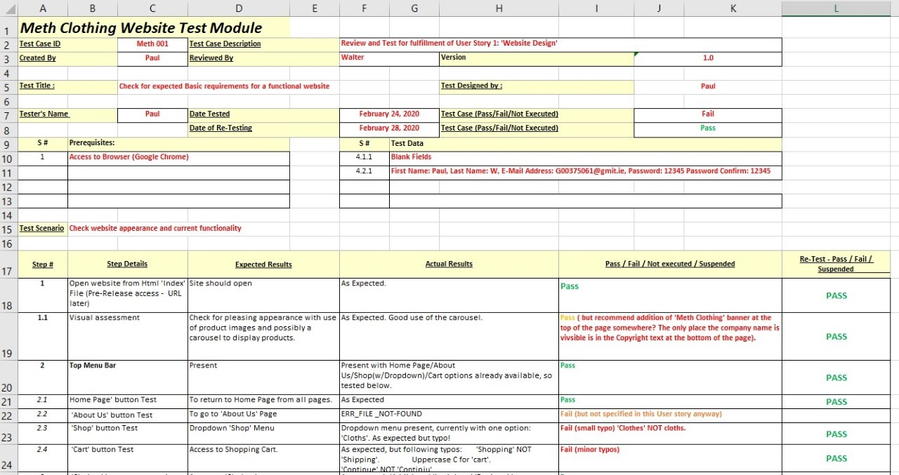

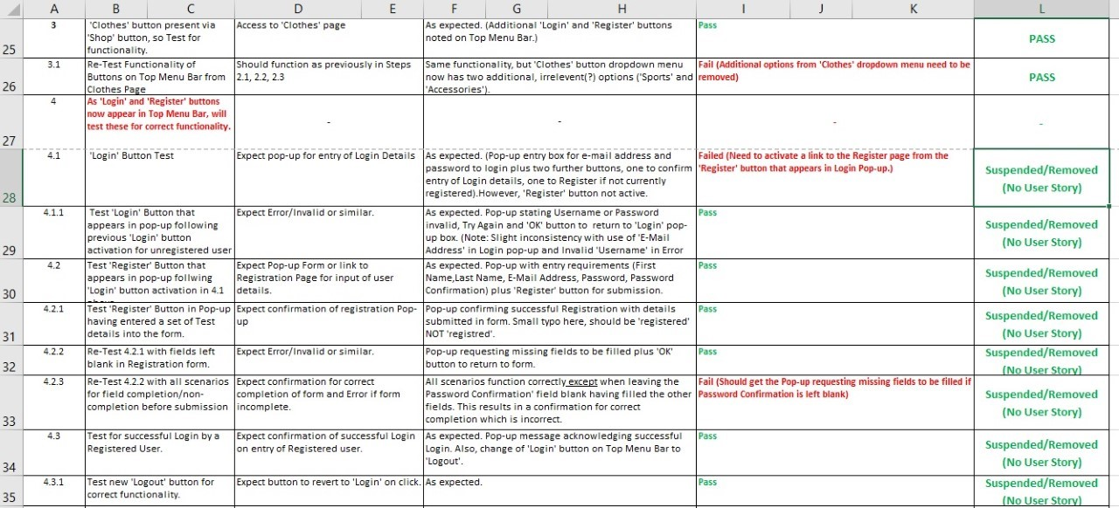

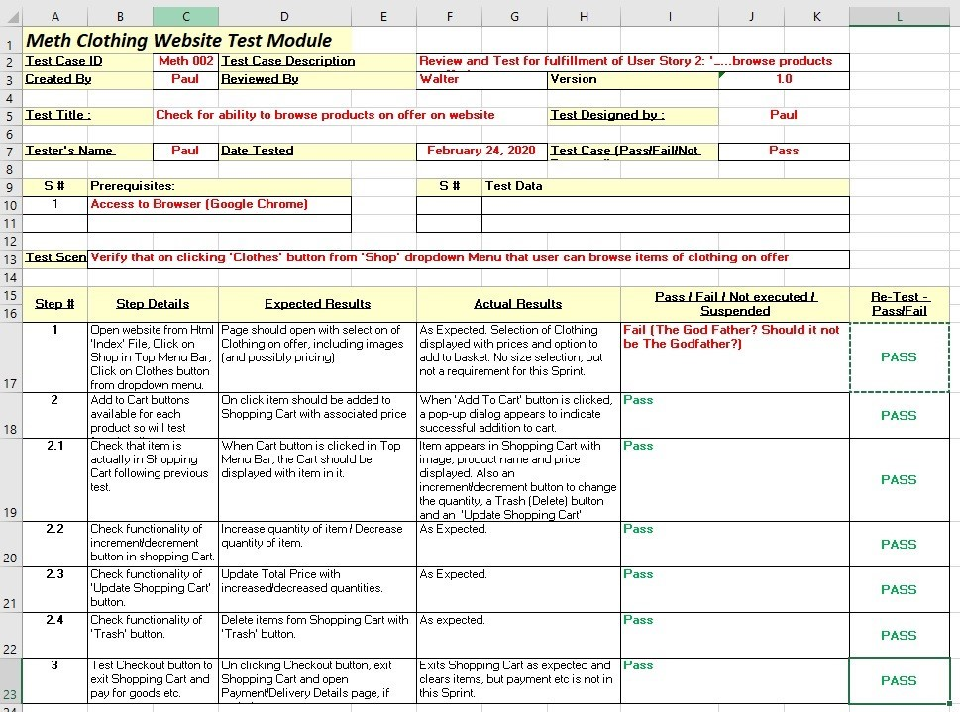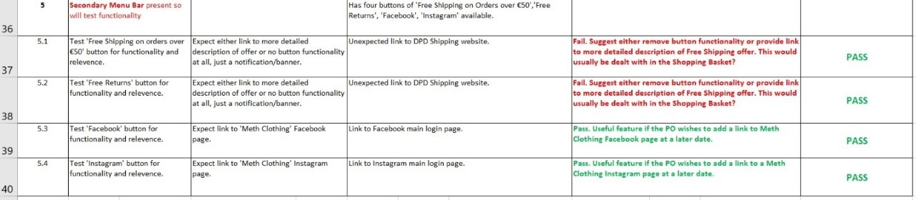

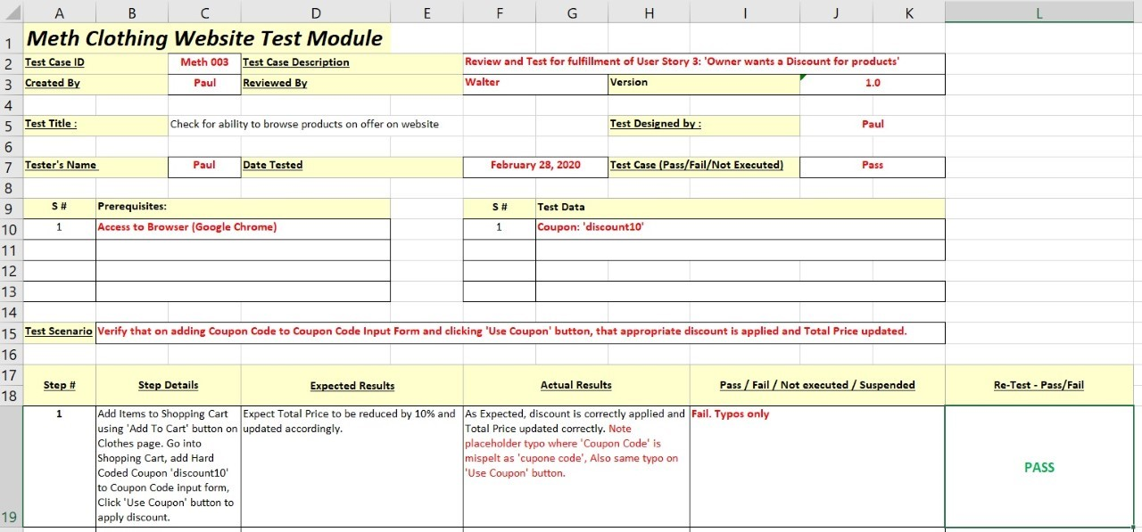

Submitted By: Paul Whent

On behalf of Team 'Matrix Reloaded'

**Monday 9th March 2020 Monday Stand Up All team members present. 08:50**

06 March 2020

22:03

This week’s target was to meet the requirements for Assignment 5c surrounding Sprint 2 and hopefully submit same. As the week progressed it became evident that GMIT was in imminent danger of closing in the face of the COVID-19 outbreak, so we decided that we would make a concerted effort to complete the outstanding tasks as best we could and submit away before week’s end.

In today’s Stand-Up I reported that I had once again investigated introducing automated testing into Sprint 2 ( as had Walter as part of the SPIKE story), but again due to very limited time available with other higher priority subjects taking precedence, I had, again, dismissed any chance of doing this and would, instead stick to the manual testing as used in Sprint 1. With this decision made, I had added extra Tests/Tabs to the Excel Test Module File in preparation for testing Sprint 2 user stories.

(It has become a bit of a mantra as this project has developed, that there is not enough time to complete the multitude of tasks set, but that is the reality, and I haven’t met anyone doing this module who doesn’t feel the same way, some being more vociferous than others.

I think there is a general respect and appreciation for what Joe is trying to teach us about a very important aspect of today’s software development work environment i.e. Agile, but there is huge frustration/exasperation at the workload expected of us when we have so much work in other subjects. As a result, it appears to me that a lot of people have totally disengaged from this subject. I am fortunate to be part of a team that have endeavoured, under duress, to meet the criteria for the submissions as best we can, to at least, hopefully, get a pass. Unfortunately, in doing so, this has impinged on the time we should have been spending on other subjects. That said, with the work we have done there is no doubt that we have learned a great deal about the Agile way of doing things and are aware of the processes involved, so it’s not all bad, the workload just needs to be scaled back somewhat.)

Submitted By: Paul Whent

On behalf of Team 'Matrix Reloaded'

**Thursday 12th March 2020 Work Meeting incorporating Review/Demo** **All team members present. 13:00 - 15:00**

14 March 2020

14:48

***Thursday 12th March 2020 (Study Room 1) (13:00 – 15:00)***

Unfortunately, this meeting was cut short thanks to the rescheduling of a lecture and lab in another subject.

Emil and Stephen, despite their weekend work commitments, had somehow managed to complete their respective user stories earlier in the week and today at this meeting Paul successfully tested and completed the required documentation (Excel File) for same.

Having completed the Sprint 2 tasks, we hastily recorded our Sprint Review/Demo to show the PO the work that had been completed. Walter (PO) asked pertinent questions about the new features that the user stories for Sprint 2 had achieved and seemed very happy with the answers from the developers, Stephen and Emil.

With time running out fast, we also incorporated the Sprint Retrospective into this meeting and each member raised their thoughts on what went well, what didn’t go so well and any actions needed for the next Sprint. The resulting points raised were listed on the whiteboard and photographed as an artefact.

David updated the relevant information to Jira for the Sprint Burndown Chart etc. and agreed to compile the necessary information for Stephen to make the Assignment 5c submission to Moodle. I agreed to update OneNote as usual.

Submitted By: Paul Whent

On behalf of Team 'Matrix Reloaded'

Summary

The project

Conclusions

The project